Tóm tắt **Machine Learning Engineering for Production (MLOps) 20222**

Contents:

Course 1: Introduction to Machine Learning in Production 1

1/ Overview of the ML Lifecycle and Deployment 1

The Machine Learning Project Lifecycle 1

Deployment 1

Graded assessment 1

Ungraded Lab 1

2/ Select and Train a Model 2

3/ Data Definition and Baseline 2

Course 2: Machine Learning Data Lifecycle in Production 2

Course 3: Machine Learning Modeling Pipelines in Production 2

Course 4: Deploying Machine Learning Models in Production 2

# Course 1: Introduction to Machine Learning in Production

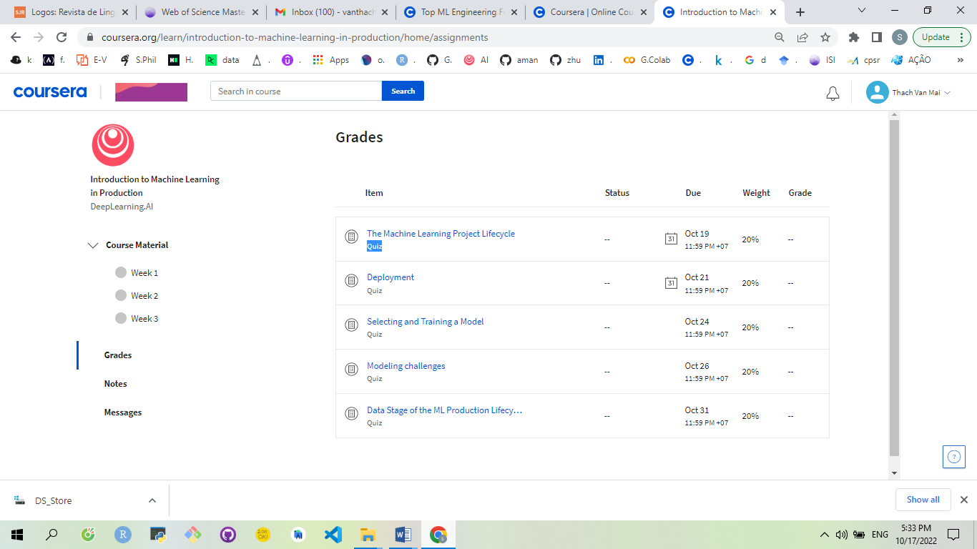

# Oct 17th - 1/ Overview of the ML Lifecycle and Deployment

## The Machine Learning Project Lifecycle

### Welcome (p.3)

<https://www.coursera.org/learn/introduction-to-machine-learning-in-production/lecture/uoVS1/welcome>

Steps of an ML Project (p.8)

<https://www.coursera.org/learn/introduction-to-machine-learning-in-production/lecture/PhRTU/steps-of-an-ml-project>

Case study: speech recognition (p.10)

<https://www.coursera.org/learn/introduction-to-machine-learning-in-production/lecture/bwXgc/case-study-speech-recognition>

Course outline (p.15)

<https://www.coursera.org/learn/introduction-to-machine-learning-in-production/lecture/wiwsM/course-outline>

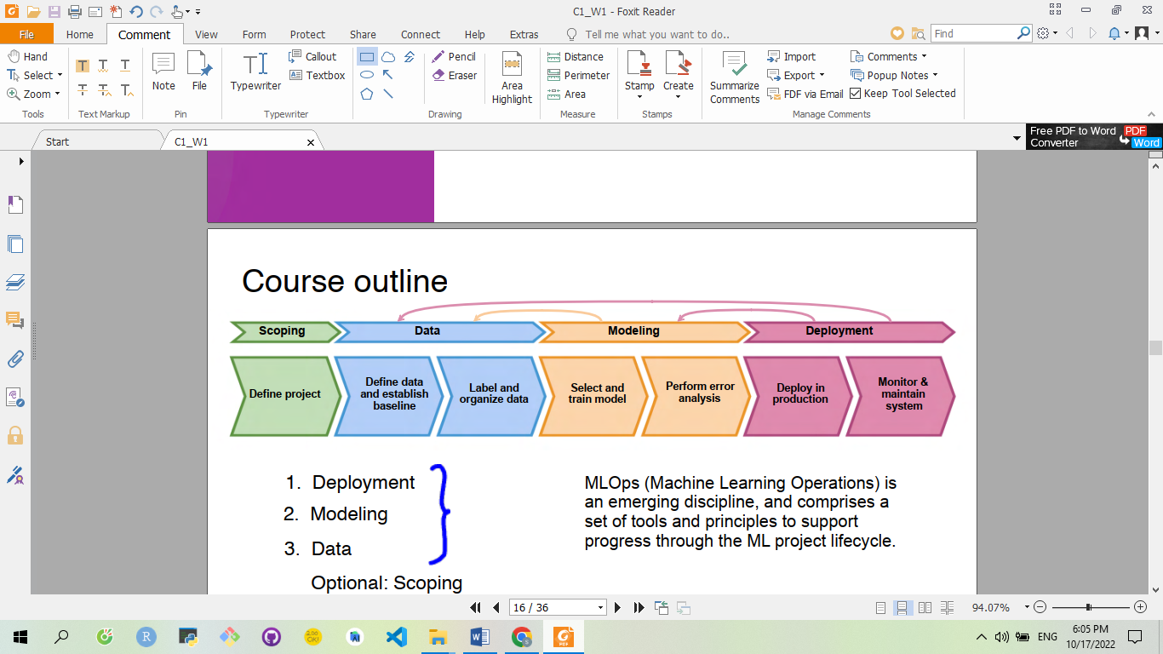

## Deployment

### Key challenges (p.17)

<https://www.coursera.org/learn/introduction-to-machine-learning-in-production/lecture/k9iID/key-challenges>

## Graded assessment

## Ungraded Lab

# 2/ Select and Train a Model

# 3/ Data Definition and Baseline

-----------------------------------------------------------------xxx---------------------------------------

# Course 2: Machine Learning Data Lifecycle in Production

1: Collecting, Labeling and Validating Data

2: Feature Engineering, Transformation and Selection

3: Data Journey and Data Storage

4 (Optional): Advanced Labeling, Augmentation and Data Preprocessing

-----------------------------------------------------------------xxx---------------------------------------

# Course 3: Machine Learning Modeling Pipelines in Production

1: Neural Architecture Search

2: Model Resource Management Techniques

3: High-Performance Modeling

4: Model Analysis

-----------------------------------------------------------------xxx---------------------------------------

# Course 4: Deploying Machine Learning Models in Production

1: Model Serving: Introduction

2: Model Serving: Patterns and Infrastructure

3: Model Management and Delivery

4: Model Monitoring and Logging